Research Riders Meeting Topics
April 14, 2011 12:00pm
Building 71 Main Conference Room
Call to Order.

Treasurer’s report:

Report from Sandra on current treasury status.
We have one gas cards given to the lucky finder of the Landmark, but James has yet to post it……….

Old Business Section:

- Any revisions to last month’s (March’s) minutes? Move to accept
- “Find the Landmark” game is on hold until we get the new landmark from James Mathis…..
- March Ride Report – The “St Patrick’s Day Parade was another big success, with the Research Riders again winning the trophy for what we’re not exactly sure, but it was a great time. Riders included Patrick, Joe, Louie, James, Sandra, Purser, Daniel, Margie, Scott #1, Scott #2, Mark, Greg and Liz. We met up at the Pig Stand on Broadway for some pre-ride breakfast, then assembled on Avenue E to decorate the bikes. Lots of green and craziness. There was a pretty good crowd downtown to cheer us on, and the day was not too hot, so all went well. That evening Mark hosted his annual St Patrick’s party at his house, and several riders attended that too. A good day overall!
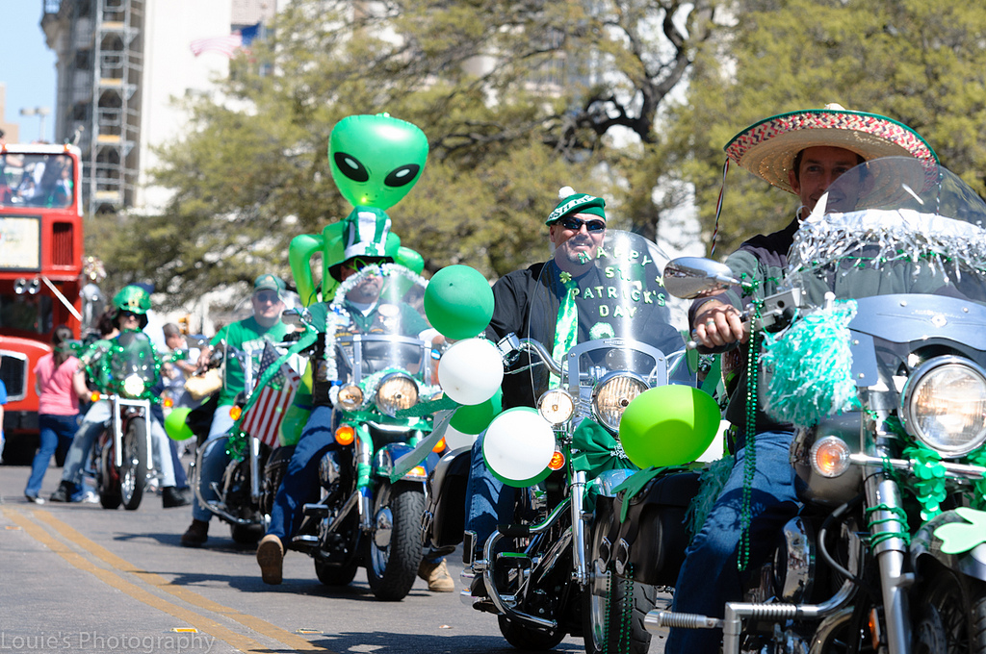

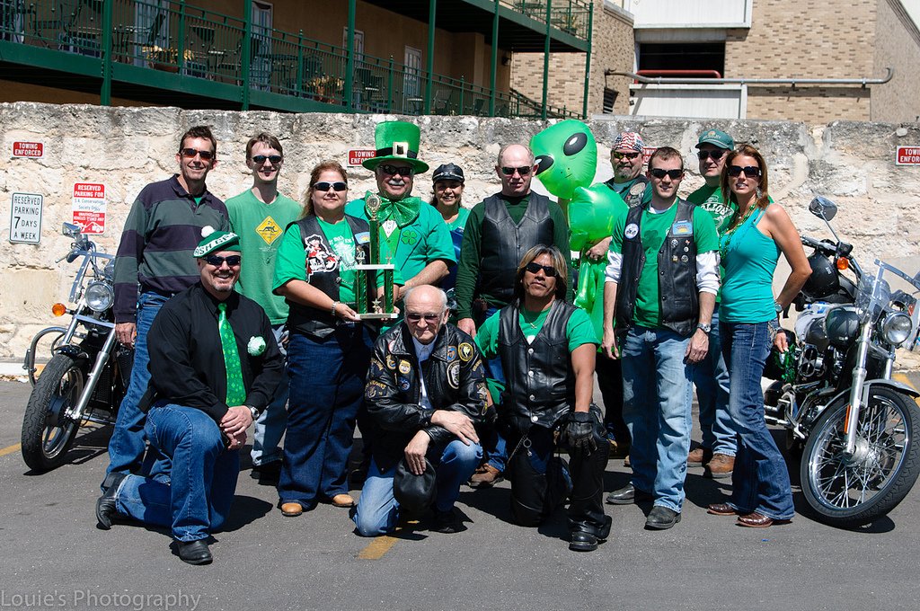
- Bike to breakfast – A group of about 8 of us met at the SwRI cafeteria Friday April 1 and had breakfast together in the second rendition of our planned monthly ride-to-work and eat idea. We parked together for a show in the parking lot, and shot the breeze until it was time to head to work. Stay tuned for next month’s date.
- South Texas Motorcycle Show. On Saturday March 26th a group of 8 riders met up and headed to the big show as a group (actually Scott, Sandra, Greg, Bob, Malva and Patrick met for breakfast and Scott & Michelle met them at the gates). There were lots of bike to ogle, vendors, a classic car show, and stunt riding by Clint Ewing, who can definitely ride that crotch rocket like it’s a extension of his body. Don’t do this at home kids.
- The Annual Multi-day Ride heading into Louisiana and New Orleans on the long weekend of May 27 – 30 which encompasses Memorial Day (Friday-Monday). The organizing committee of Patrick, Louie, Sandra and Scott met at Patrick’s place and mapped out a route plan. The basic plan laid out was this – plan the ride to see sites along the way and have enough time to take in sightseeing spots while there. Ride about 100 miles or less at a stretch between breaks. Louie Junior is planning on accompanying us so we’ll have some car support, which is good because we’ll have a place to lock up our bags when we head into sightseeing places. Ideas are presented below. Lets discuss the pros and cons, then the committee will identify the hotels and the stopping spots.

- Friday day 1. Drive to Lafayette LA on I10 all the time and it’s about an 8 hour ride on a motorcycle, not stopping much, just gas and a bit of eating. Seeing all the fancy truck stops. It’s about 412 miles on I-10.
- He suggests day 1 would be head to Port Arthur, TX instead. This is 285 miles, about 5 hours. We could leave on Thursday after work or perhaps a little early like at 4pm, and get there in time to crash out. Take I10 to get there, pass through Houston after rush hour (7pm or so).
- Alternative Friday day 2. Take to southern scenic route out of Port Arthur south into LA through the low areas of Louisiana – lots of good scenery, waterways, big trees, etc along Hwy 82 and 87. Plan to stop in Jefferson Gardens, where they make Tabasco, have sightseeing there, alligators, gardens, bird sanctuary – a tour time of perhaps 3 hrs. Then head up to the New Iberia area for the night, good restaurants, etc. This would be Friday. Miles would be about 170, but the day would be more relaxed with a few stops, a ferry ride, seeing a few sites.
- Day 2/3 Saturday we head down scenic route 182 until it merges with Hwy 90, into New Orleans. Nice views, plantations along this route. This is 134 miles, and might take 4 hours. We get in around 1pm, to the hotel, park the bikes, trolley to the French Quarter for an afternoon and night of site seeing.
- Day 3/4 Sunday we head out over Lake Pontchartrain, west via I12 into Baton Rouge (some sites to see, good eating), then across the Atchafalaya swamp on I10 (lots of riding over water this day), and head into Lake Charles for the night and casinos. 237 miles this day.
- Day 4/5 Monday we head back home via I-10, a distance of 340 miles, about 7 or so hours depending on how long we stop to eat or sightsee at the truck stops.

New Business Section:
- Updates from Publicity / Ride activities in Texas Committee – Mark
- New Riders E-Mail Account – Mark
- Ride –To-Restore-Life April 16th Leaves Javelina Harley at 9am, loops 410 with a police escort, and ends up at Sunset Station at 11 for food and music. The link below gives some info; perhaps a group of Riders can make it there together.
http://www.thecircleforlife.com/

- Research Riders Group Ride for April – let’s plan to do one on the 23th (before Easter). Need to select a date and a ride leader. (Louie)
- Next day for the Bike-To-Breakfast. First Friday of May, the 6th, meet at the SwRI Cafeteria at 7:15 am!

Open Discussion:
- Open topics from the floor

