Research Riders Meeting Topics
March 10, 2011 12:00pm
Building 71 Main Conference Room
Call to Order.

Treasurer’s report:

Report from Sandra on current treasury status.
We have one gas cards given to the lucky finder of the Landmark, but James has yet to post it……….

Old Business Section:

- Any revisions to last month’s (February’s) minutes? Move to accept
- “Find the Landmark” game is on hold until we get the new landmark from James Mathis…..
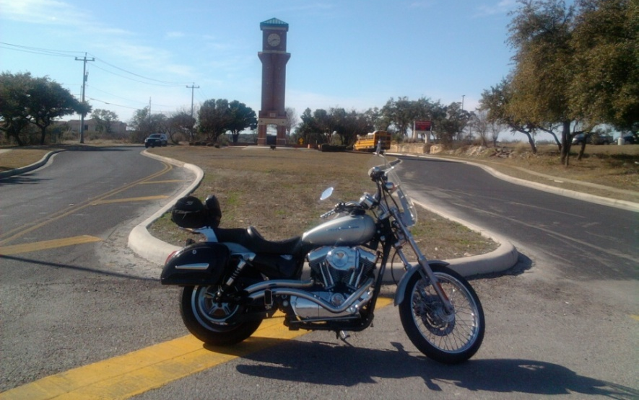

James found Dustin’s Secret Landmark Location on Jan 31

- February Ride Report – The “South Side of Town” route shown below was run by Scott, Daniel & Margie Garcia Feb 26th. The three of us met at Caliente Harley, waited a bit until the light rain quit, then headed out. It was a real nice ride with great weather. The last few quiet roads on the way to Texas Pride BBQ were especially scenic. The food there was really good and we decided we’ll have to head that way again sometime. (Scott)

- Bike to breakfast – A group of 9 or 10 of us met at 7am at the Library and headed over to the SwRI Cowboy Breakfast (Friday, Feb 25th). We ate the free food and waited on the coffee and shot the breeze until it was time to head to work. It was a relaxing time and a good start to our planned monthly ride-to-breakfast. Stay tuned for next month’s date. (James)
- St Patrick’s Day Parade – Saturday! As is tradition, a group will meet at the Pig Stand on Broadway at 8:00am for a pre-parade breakfast. For those who want to, a meet-up at the SwRI Credit Union at 7:45am will occur for a group to ride to Pig Stand. The parade starts at 11am, and the line-up starts at 9am. Judging occurs around 9:30am. Let’s have a great turn-out – this one is real fun. Decorate yourself and your bike, ride slow and make lots of noise, wave to the crowds. You need a vehicle pass if you’re going – I have them for all attending and will have extras at breakfast. If you can’t make breakfast no problem join us at the area marked “G” on the map below. See you there! (Scott)

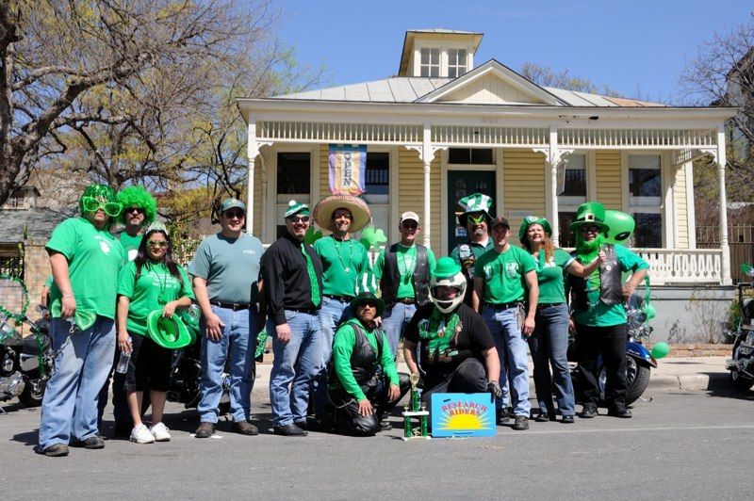

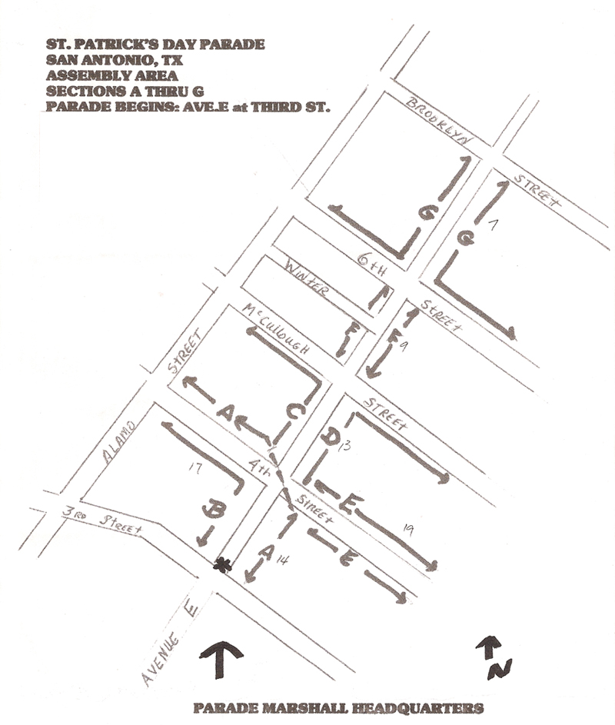

- POLAR BEAR COMPETITION – its officially OVER and Sandra will report the mileage and the winner! Go to the meeting to find out who wins the coveted Polar Bear patch…(Sandra)
- The Annual Multi-day Ride voting results are in and the highest vote getter was: heading into Louisiana and New Orleans on the long weekend of May 27 – 30 which encompasses Memorial Day (Friday-Monday). We need to organize a planning committee today and work hard on the route and planned stopping areas, sites to see, etc. Volunteers? Scott will be one, Road Captain Louie, others... (Scott)
- The South Texas Motorcycle Show is coming to Freeman Coliseum March 19-20. Bike vendors, mucho parts, stunt rider Clint Ewing, bikini teams, roller derby, everything motorcycle in one place. Who wants to meet up to go as a group – perhaps Saturday the 19th around noon? Tickets to get in are $15 at the door, $10 in advance at HEB, Alamo CyclePlex, Kent Powersports, South Texas Suzuki.
http://txbikeshow.com.

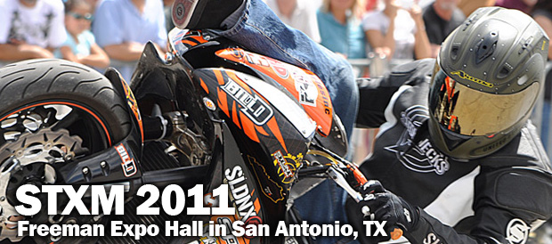

New Business Section:
- Updates from Publicity / Ride activities in Texas Committee – Mark
- Group Ride for March – let’s plan to do one either the 26th or 27th so we don’t interfere with the South Texas Motorcycle Show. Need to select a date and a ride leader. (Louie)
- Lets plan a day for the next Bike-To-Breakfast. I think we said first Friday of the month previously. Mark your calendars for Friday, April 1, 7:15 or 7:30?? SwRI Cafeteria.

Open Discussion:
- Open topics from the floor

