Research Riders Meeting

Meeting Minutes
January 12, 2012
- Call to order
Patrick Keller called to order the regular meeting of the Research Riders at 12:05pm on January 12, 2012 in SWRI Cafeteria.
- Attendance
The following persons were present: Patrick, Louie, James, Scott, Bob, and Malva
- Approval of minutes from last meeting
The minutes were from last meeting were distributed and approved.
- Treasurer’s Report
Treasury contains $350.68. Rider’s Roster has been finalized and 16 employee names will be submitted to RRA for funding.

- Old Business
- Louie, Patrick, Scott, Greg, Richard and Sean represented the Riders at the Blue Knights Annual Toy Drive Dec 10th at VFW on Valley Field. They met for breakfast and joined the group for a slightly early takeoff at 10:30 am. The parade ended at Mission Road Development Center where gifts were distributed to the MRDC Kids. (pictures attached)
- Meet at Caliente Harley on Saturday, Jan 28th. We’ll have out kickstands up at 10:30 am. Planning to head west to Rio Medina, and then turn south to Castroville. Ride to Lytle, then head east to Somerset. Stretch the legs. Take a southeasterly route to Floresville, then northeast into Adkins and Texas Pride BBQ for FOOD. Check out the link. http://www.texaspridebbq.net/
- St. Patrick’s Day ride has been canceled for this year. The escalating costs of the parade of over $12,000 for the permit, barricades, police, insurance and the reviewing stand and lack of city support and assistance made it impossible for the Harp and Shamrock org to continue this tradition. www.harpandshamrock.org.
- Photo Challenge: You, Your Bike and a Cattle Guard won by Patrick.
Next challenge : You, Your Bike and
- Polar Bear Competition begins Feb 1 and lasts until Feb 29th. The most mileage accumulated during the month wins. Please send Bob Burrahm (designated judge for the competition) your odometer reading on your motorcycle no earlier than midnight January 31st. The winner receives a Polar
Bear patch.

- New business
- Multi day ride will be held Labor Day weekend May 24th or 25th to May 28th. Members will be polled to see if they would like a 4.5 day trip to Cloudcroft, NM
Cloudcroft, New Mexico is….
- 40 miles from casino wagering at Inn of the Mountain Gods.
- 50 miles from Ruidoso Downs.
- 16 miles from the Space Museum, Alameda Park Zoo, and Toy Train Depot in Alamogordo.
- 40 miles from White Sands National Monument.
Or a shorter 3 or 4 day ride to either Big Bend
People visit Big Bend to hike, camp, ride horses, paddle the river, pedal bicycles, ride motorcycles, look for wildlife, look for nightlife, or
The Piney Woods is sometimes referred to as East Texas or Deep East Texas so named because much of the region is covered by tall pine tree forests. The Piney Woods Region is where the Texas Oil Boom began, in towns like Kilgore, Longview and Marshall. You can see the Spanish influence in the Piney Woods Region in towns like Nacogdoches, which began as a Spanish fort in the 1700s. Caddo Lake is the only natural lake in Texas.

- February ride we will consider a rodeo ride or a ride to the coast.
- Members will be polled to see if they are agreeable to sharing member info including their phone numbers with the other members.

- Adjournment
Patrick Keller adjourned the meeting at 12:55 pm.
Minutes submitted by: Malva Burrahm
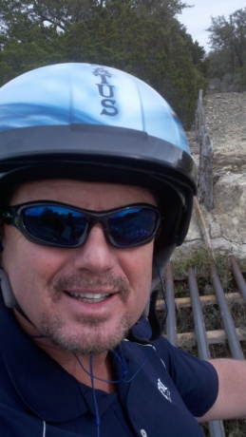 Winning photo!
