Research Riders Meeting Topics
July 14, 2011 12:00pm
Building 71 Upstairs Conference Room (again, at the top of stairs)
Call to Order.

Treasurer’s report:

Report from Sandra on current treasury status. When do we submit to the RRA for Club money?

The last gas card went to Malva Burrahm, as she and Bob found the last Landmark, the windmill at the Hill Country Hyatt off Hwy 151. Congratulations to Malva & Bob! Now we are onto a new motorcycle game – see below (Magic….).

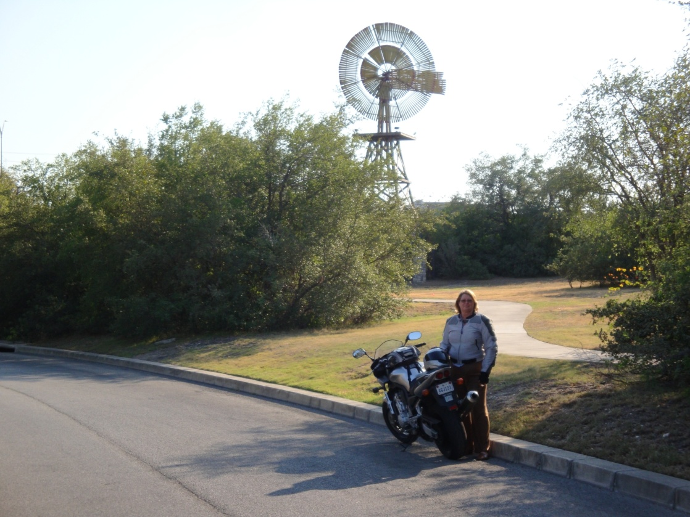

Old Business Section:

- Any changes to the minutes submitted for the June meeting? If so, state them for the record, if no, we’ll move to accept them.
- “You, Your Bike, and ??” game as suggested by Don Moravits the last couple meetings will be our next “official” club contest. Don can perhaps review the game again. And, Don we are looking to you to start us off with the initial picture. [Don]
- Ride–To-Work day Monday June 20th. A group of 4 riders (Don, Sandra, Scott, Craig) met at the SwRI cafeteria for breakfast to recognize the national Ride To Work day. They are a non-profit motorcycle advocacy group that sponsors the ride to work as a way to raise awareness of motorcycles to the general public. Breakfast was good, as was the conversation. Being on a Monday made it difficult for many folks to remember the event… We did notice a number of other riders heading into SwRI as we talked in the parking lot that morning..[Scott]
- Bike to breakfast Friday, July 1st– A group of 6 riders (Don, Sandra, Scott, Patrick, Louis, Mark) met at the SwRI cafeteria for breakfast and to swap stories before the work day. Also on display was Patrick’s brand new paint job, which has to be seen to be appreciated. [Patrick]
- ROT Rally – several of us met in Austin on Friday June 10 to watch one of the biggest bike parades rallies in the whole country, on Congress Avenue. Mark & Michelle, Scott & Michelle (another Michelle, not the same woman), James & Liz met up with a few friends and family to watch the huge parade. All types of bikes, dominated by the big V twins from HD, great paint jobs, many customs, and a few typical Austin weirdness – favorites being the nerdy guy in sandals on a scooter, right in there with all the bad-asses, and the woman in the lycra cat outfit, from head to toe, riding on the bike painted in cat stripes. A good time was had as we checked out all the bikes parked on 6th street and had some refreshments in the clubs there. [James]
- Research Riders Group Ride Saturday, June 25th At the relative cool of 8:30am, Bob & Malva Burrahm, Scott Mullin, and Daniel and Margie Garcia met a the Valero at 1604 & Bulverde Road for a real nice ride into the north side Hill Country, up to Canyon Lake, and down River Road to Gruene. The weather was good and the ride was real nice – quiet roads for the most part, great scenery, and River Road was real nice even with the Guadalupe being rather low. Didn’t scare away the campers – every piece of grass was covered in tents. We stopped in Gruene for a stroll and refreshments (ice cream, of course), then headed west on Hwy 46, and then down Blanco to Specht’s Store for a good lunch. It was actually nice on the back patio in the shade with a breeze. After lunch we headed home before the real heat came up – a real nice ride and just long enough this time of year. [Bob}

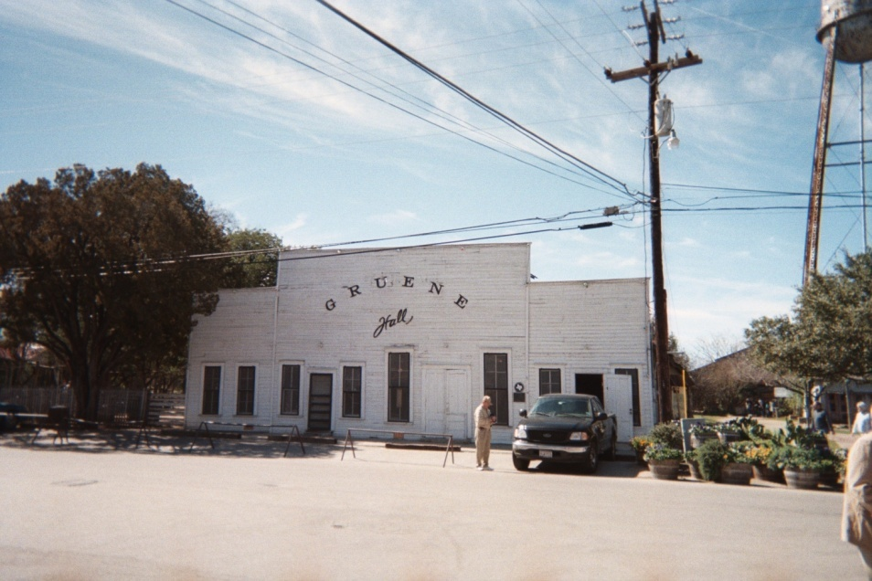

- Mark to discuss the Riders G-mail account: rridersevents@gmail.com – right address, Mark?

New Business Section:
- Updates for July / August from Publicity / Ride activities in Texas Committee – Mark
- The Annual Multi-day Ride heading into Louisiana and New Orleans was postponed until September or October.. The same route will be done, a 4-day ride east to see swamps, the coastline, Tabasco factory, New Orleans, air boat rides, and a casino visit. Let’s do some advance planning for dates.
- Our annual Research Riders Club Picnic is usually in September. Dwayne suggested we look into another State Park venue, and those who want to can make it a bike camping trip and spend the night. Enchanted Rock, North of Fredericksburg, Guadalupe River State Park, Garner State Park/Chalk Bluff, others. Let’s look at the calendar and pick some dates here too.
- July Club Ride. It’s still hot….so let’s either pick an early start time, or, an evening ride. Suggestions? Morning: Kendelia, Crabapple road, up to the Bowling Alley in Blanco for breakfast? A route south of town, heading towards Poth or that area for grub? A ride close to town, stopping along the Riverwalk for lunch? An evening ride – see the bats? Head to Luckenbach or Bandera? Ideas from the floor. [Louie]
- Next day for the Bike-To-Breakfast. First Friday of August, the 5th meet at the SwRI Cafeteria at 7:15 am! Mark your calendars

Open Discussion:
- Open topics from the floor

