Research Riders Meeting Topics
August 11, 2011 12:00pm
Building 71 Downstairs Conference Room
Call to Order.

Treasurer’s report:

Report from Sandra on current treasury status. When do we submit to the RRA for Club money?

Old Business Section:

- Any changes to the minutes submitted for the July meeting? If so, state them for the record, if no, we’ll move to accept them.
- The Annual Multi-day Ride heading into Louisiana and New Orleans: decision on the date, by popular vote is Sept 29 – Oct 3 or Oct 6 – 10. Final counts will be given. Route -- a 4-day ride east to see swamps, the coastline, Tabasco factory, New Orleans, air boat rides, and a casino visit. A great time in the making.
- Our annual Research Riders Club Picnic will be in September. Dwayne suggested we look into another State Park venue, and those who want to can make it a bike camping trip and spend the night. Enchanted Rock, North of Fredericksburg, Guadalupe River State Park, Garner State Park/Chalk Bluff, others. Patrick checked and we can also use the Shriner’s River Camp facility (picnic areas, pool, river-front). Decision on the date, by popular vote is Sept 10 or 24. Final counts will be given. .

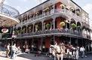 | 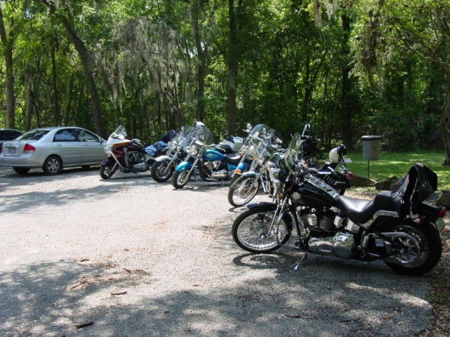
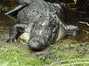  New Orleans / Louisiana Trip!! | 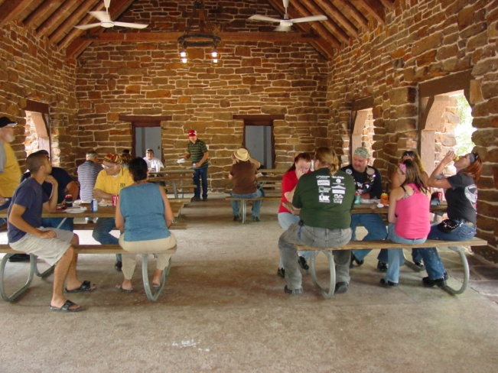  Annual Picnic – State Park!
Vote for Days: | Vote for Days:
Sept 29 – Oct 3 o Oct 6 - 10 | Sept 10 or 24

- New Officer Elections – Final vote counting and installation of new officers. The slate of volunteers is
  - President – Patrick Keller
  - Vice President – Sandra Meckel
  - Secretary – Malva Burrahm
  - Treasurer – James Mathis
  - Senior Road Captain – Louis Preciado
We will present the counts of all received via e-mail to date, and take extra votes from the floor. These will be summed and the new officers installed! Secretary – present the counts. Thanks to the nominating committee (Bob, Daniel, Scott).

- Bike to breakfast Friday, August 5th– Good turnout this month – 12 riders! (Don, Sandra & Scott Meckel, Scott Mullin, Patrick, Louis, Bob & Malva, Craig, Bobby Theis, James, Mark) met at the SwRI cafeteria for breakfast and to swap stories before the work day. Good to see a few new faces – keep them coming!
- “You, Your Bike, and ??” game as suggested by Don Moravits officially started at the last meeting, but we really didn’t get the word our very well, so, here it is again. The picture must have:

YOU, YOUR BIKE, AND A TEXAS FLAG ON A REGULATION FLAG POLE, NOT ON THE SWRI GROUNDS.

New Business Section:
- Updates for August / September from Publicity / Ride activities in Texas Committee – and discuss the Riders G-mail account: rridersevents@gmail.com – Mark
- August Club Ride. It’s hotter still….so let’s either pick an early start time, or, an evening ride. Suggestions? Morning: Kendelia, Crabapple road, up to the Bowling Alley in Blanco for breakfast? A route south of town, heading towards Poth or that area for grub? A ride close to town, stopping along the Riverwalk for lunch? An evening ride – see the bats? Head to Luckenbach or Bandera? Ideas from the floor. [Louie]
- Next day for the Bike-To-Breakfast. First Friday of September, the 2nd. Meet at the SwRI Cafeteria at 7:15 am! Mark your calendars

Open Discussion:
- Open topics from the floor

