Research Riders
Ride Report. Annual Picnic Ride September 17, 2011

On the cool, slightly rainy Saturday morning a group of 6 motorcycles and with two passengers met at the Exxon on I10 & Ralph Fair Road: Daniel and Margie Garcia, Bob and Malva Burrahm, Joe Stateson, Greg Rawson, Tim Cade and Scott Mullin. Sandra Meckel met us there to send us off. These intrepid groups headed out north despite the threat of rain, and were rewarded with great riding weather, dry roads, and only a few minor rain spats along the way.

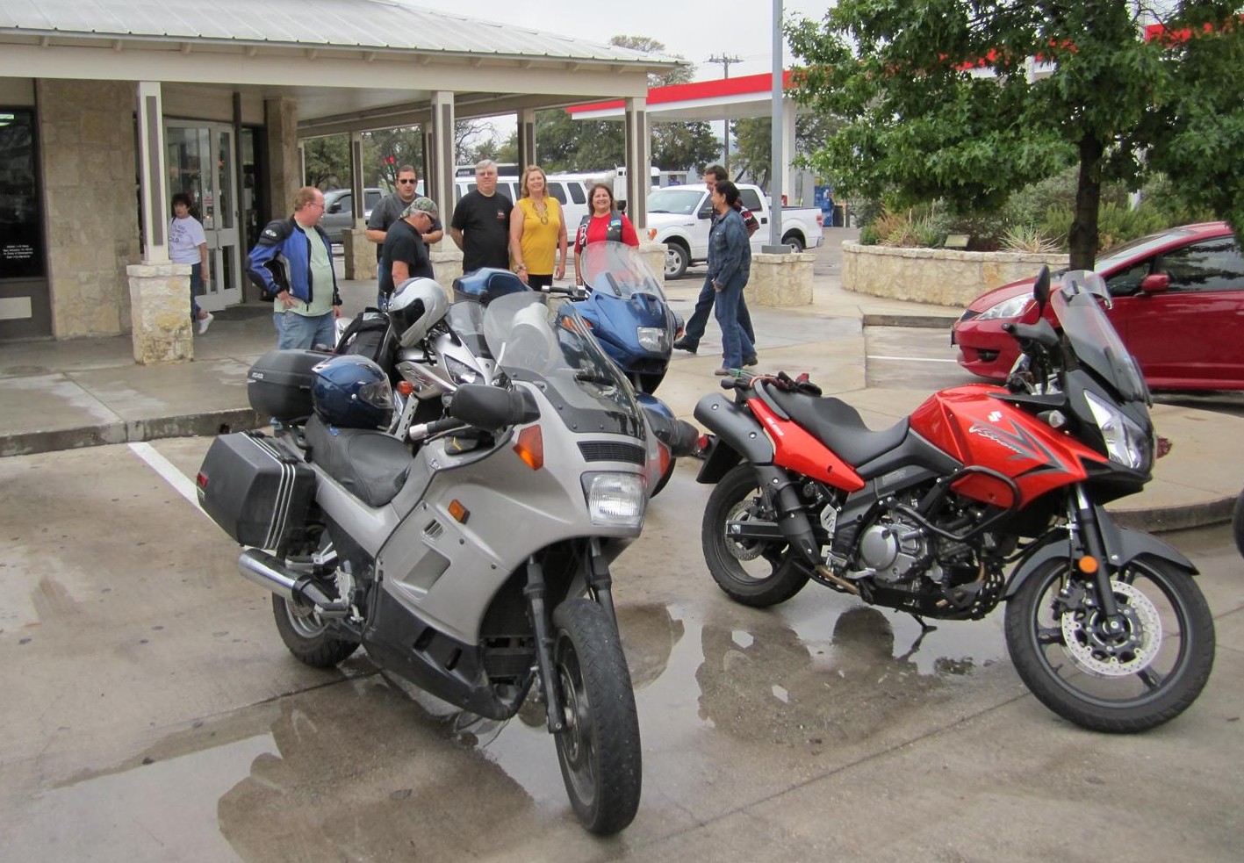

The route took us along some very nice scenic Hill Country ranch roads that had very little traffic. We started on FM 3351, and headed NW just past Bergheim onto Edge Falls Road. This fine ranch road is mostly winding single track, with multiple cattle guards and views of the Guadalupe river and other creek beds. It ends up at the country store in Kendelia, so we stopped there and had a drink. After that we headed up one of my favorite roads, Crabapple Lane, going north from Kendelia up to the Blanco area. More scenic single track road, lots of hills, great views, and a low water crossing of the Blanco River. We then rode west onto 1888, which eventually meets 1376, where the group decided to detour north a bit and drop into Luckenbach. Great idea. There were many other bikes there, good drink to be had, and the always fine relaxed atmosphere in that place. It was hard to leave, but we knew others were waiting for us in Leon Springs, so we headed south on 1376 all the way to Boerne. A quick jaunt down I10 brought us to Rudy’s BBQ, where Sandra (thanks Sandra!) had already got the club a great BBQ meal ready. Besides having Sandra join us, Purser Sturgeon and his family, Dustin Knoll and Jennifer, Joe’s girlfriend, Patrick Keller, and Steve Clay dropped in to share in the meal. A good time was had by all! Report by Scott Mullin.

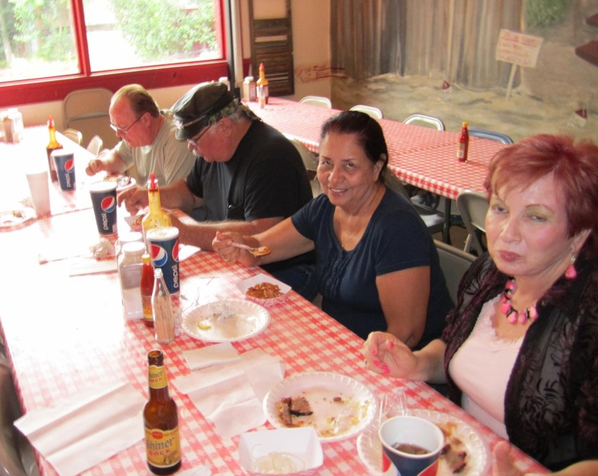 | 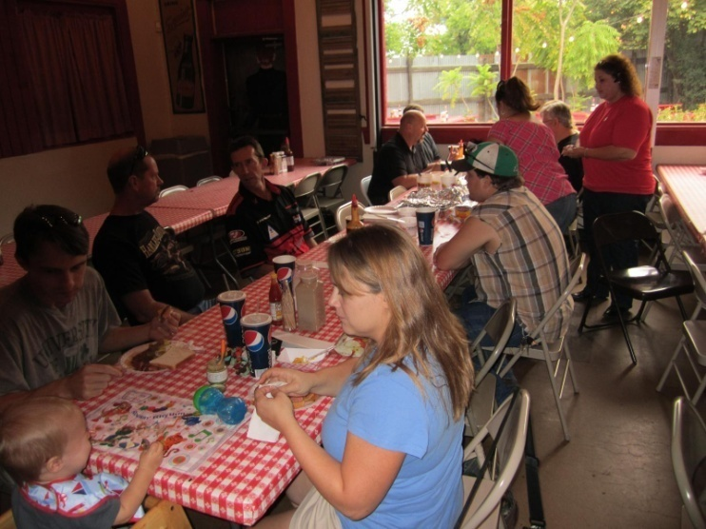
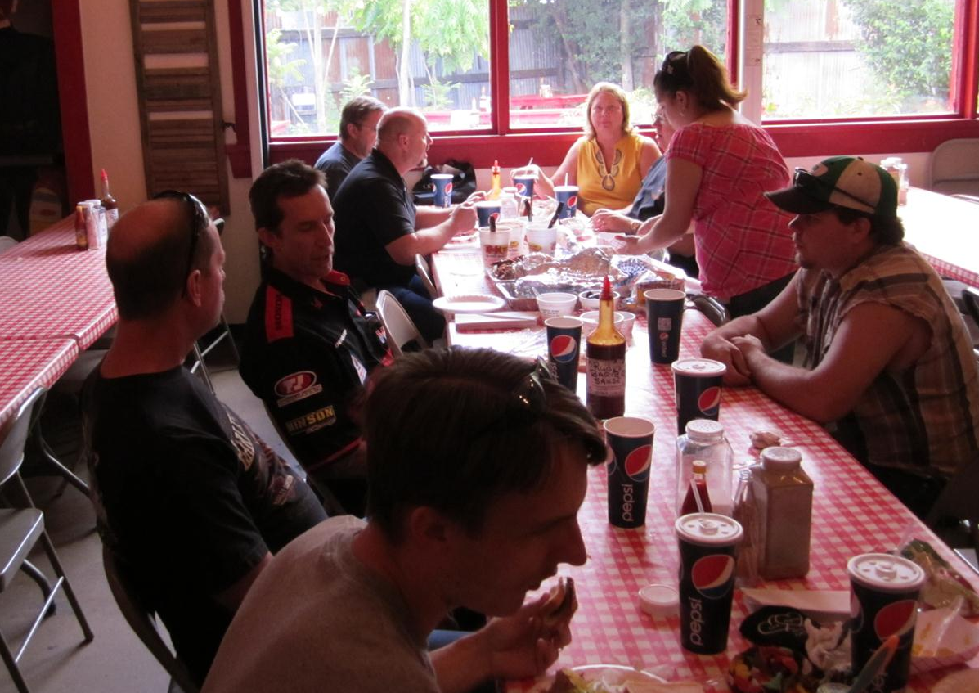 | 